The Northern Club
Hockey Fixture
COVID-19 Guidelines
for Visiting Teams

As a visiting team or official, we would be grateful at the Northern Club if you could please familiarise yourself with the following guidelines to ensure a safe environment for everyone.
Please note that this guidance does not include the guidelines and advice given by the government or England Hockey http://www.englandhockey.co.uk/page.asp?section=2633&sectionTitle=Covid%2D19+Club+Support and you should consider those in addition to the guidance given below.
General guidance
- Teams and officials should bring their own hand sanitiser for players and ensure that hands are sanitised upon entering and exiting the pitch as well as during intervals of play.
- Only spectators from a juniors safeguarding perspective should attend (one parent/carer). Spectators should remain socially distances at all times and not mix
- All attending the venue should observe social distancing rules when not in play. Team huddles, handshakes and gathering in goals at half time should not take place.
- The away team should place their kit bags and equipment on the opposite side of the pitch to the home team. The away teams area is the side line closest to the car park gate.
- Players should bring their own water and equipment.
- Please use the pitch bins provided or take all rubbish home – do not leave empty bottles or litter on the pitch for others to pick up.
- You should not travel to the venue if you have COVID-19 symptoms.

Parking: The away team is requested to park in the Chestnut Avenue car park at the Northern Club (please see the map below). Should this area become full, then the other car park off Elm Ave may be used.
Away team parking
Entrance to away team car park
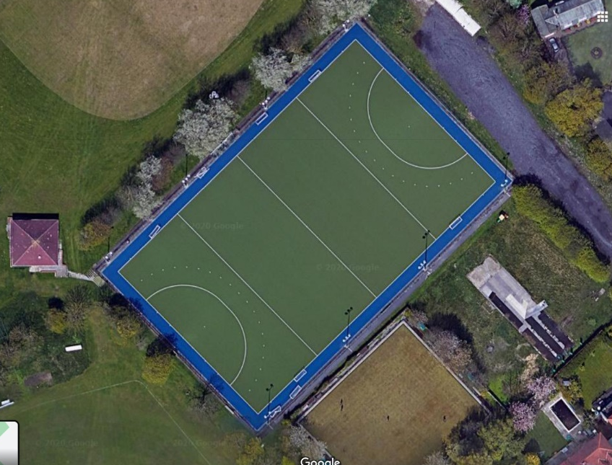
Changing facilities and toilets: Changing and shower facilities remain closed inline with government guidance. Toilets are available at the club in the Tiffin building which is next to the pitch (please see map below), however only one person should enter the changing facility / toilet at one time. When using the toilets, visitors should use the disinfectant spray provided before and after use of touch points and wash hands thoroughly both before and after using the facilities. All doors inside and outside the building should remain open to help manage touch points.
Away team pitch entrance and car park
Tiffin – Changing facilities / toilet
Entering and exiting the pitch
As noted, players and officials should sanitise their hands upon entering and exiting the pitch. Away teams should enter the pitch at their allocated gate by the carpark (please see map below). Players should not enter the pitch whilst the previous match is underway, and space should be given for the prior match’s players to exit the pitch.
Home team pitch entrance
Away team pitch entrance

Teas and refreshments
Outdoor refreshments from the club house will be available from the 12th April. Captains will advise teams of arrangements in pre match communications
Track and Trace
Away teams are responsible for their own track and trace registration and submitting of information to England Hockey. If any of your players develop symptoms within 2 days after playing at the club, or have a positive test result please contact our Covid Officer to advise of this which is Simone McCaskill Tel: 07939864592 Simone.McCaskill@hotmail.com

Directions
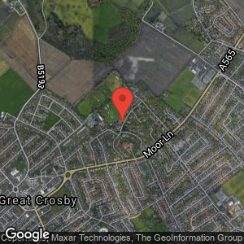
Address: Moor Park, Elm Avenue, Crosby, Liverpool, Merseyside, L23 2SX
Telephone: 0151 924 1594
Info: From Liverpool - Follow A565 through Crosby village to a roundabout, continue on A565 (third exit) and then take the fourth road on the left, Poplar Avenue which is signposted to the Northern Club. The Northern Club is 300m on the left. From M57/M58 - At the end of the motorway follow signs for Southport on the A5758, Brooms Cross Road. Continue on this road until a roundabout and then take the first exit onto the A565. Continue through two major sets of traffic lights shortly after each other. After passing the second set of lights, take the second right into Chestnut Avenue then continue down Chestnut Avenue until you find the car park entry gate on the left, just after the turn off to Elm Avenue.

Thank you for adhering to our guidelines and we hope you enjoy your visit!

